

**Program: ESE 4009**

**INSTRUCTOR:** Prof**.** Mike Aleshams

# Group# 1

|  |  |  |
| --- | --- | --- |
| Student Name | Student ID | Signature* |
| JOYAL RAJU | C0749019 | JR |
| MERLIN MARIAM THANKACHAN | C0748721 | MMT |
| SRUTHY KRISHNAN | C0749122 | SK |

*\*By signing above, you attest that you have contributed to this submission and confirm that all work you have contributed to this submission is your own work. Any suspicion of copying or plagiarism in this work will result in an investigation of Academic Misconduct and may result in a “0” on the work, an “F” in the course, or possibly more severe penalties.*

**FINAL DRAFT**

**Project Title:**

**IoT based smart parking system using Beaglebone Black Wireless**

**Description of the latest similar system:**

In the existing system, the PIC microcontroller is the processing unit. This system uses IR sensor, which is placed at entrance to detect the presence of vehicle. When the sensor senses the presence of vehicle its output will become high and that will be fed to the microcontroller and afterwards the microcontroller decrements the number of available spots and gives the output which is shown in the form of blinking LEDs. The green LED lets the first vehicle to enter the lot and once it enters the LED changes to red and stops another vehicle from entering until the first car is parked. IR sensors are also placed at each parking spot. These sensors provide information whether a parking space is occupied or not to the microcontroller. When all the parking lots are full it will be indicated in the LCD. Here, ESP8266 Wifi module is used to transfer data to administrator for tracking the whole activity.

**Limitations of the latest similar system:**

* Processing speed is low, or improvement is possible
* IR sensors are not reliable as it can be affected by sunlight and dark object
* Interfacing ESP8266 with PIC is complicated
* GPS location is not provided for customer
* Multiple entry of vehicle is not possible at a time which makes waiting time more
* Provision for multilevel parking is not present

**Final Solution:**

* **Block Diagram**

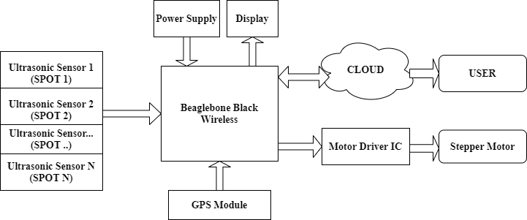

* **Features**
* Beaglebone wireless provide a processing speed up to 1Ghz and easy communication with cloud
* 65 GPIO pins are available to interface LCD and ultrasonic sensors
* Ultrasonic Sensors are used to detect the vacant spots.
* LCD will notify the drivers regarding availability of lots.
* GPS module is provided to update the parking location to user
* Uses UART_TXD and UART_RXD pins to establish UART serial communication with GPS module.
* IEEE 802.11 2.4GHz in built WIFI router will establish connection with cloud system
* ThingSpeak is the cloud system used to update the information timely to the user.
* Use preemptive scheduler to reduce the power consumption and unwanted delays and use tick rate for accuracy in the system
* Fixed task priority is used with high priority is given to ultrasonic sensors
* **Hardware and Software Requirement**
* Beaglebone wireless
* 16*2 LCD Display
* ULN2003 Driver Board
* Stepper motor
* Ultrasonic Sensors
* Adafruit Ultimate GPS Breakout board
* 5v adapter
* Jumper wires
* Debian for beaglebone
* Embedded c
* EasyEDA
* ThingSpeak cloud to store and retrieve data
* **Milestones (Deliverables and Time Schedule)**

|  |  |  |  |
| --- | --- | --- | --- |
| **Task name** | **Start Date** | **End Date** | **Person in-charge** |
| Project Proposal | June 02, 2020 | June 11, 2020 |  |
| Finalizing hardware requirements | June 12, 2020 | June 15, 2020 | MERLIN |
| Getting hardware | June 16,2020 | June 24,2020 | MERLIN |
| Testing each hardware parts | June 25, 2020 | June 29, 2020 | SRUTHY |
| Designing circuit in software | June 16, 2020 | July 7, 2020 | MERLIN |
| Interfacing Ultrasonic sensors with Beaglebone Black Wireless | July 08, 2020 | July 13, 2020 | SRUTHY |
| Interfacing LCD with Beaglebone Black Wireless | July 14, 2020 | July 21, 2020 | SRUTHY |
| Interfacing Stepper motor with Beaglebone Black Wireless | July 22, 2020 | July 28, 2020 | JOYAL |
| Interfacing GPS module with Beaglebone Black Wireless | July 29, 2020 | August 05, 2020 | JOYAL |
| Interfacing ThingSpeak with Beaglebone Black Wireless | August 06, 2020 | August 13, 2020 | JOYAL |
| PCB Designing | August 14, 2020 | August 21, 2020 | SRUTHY |
| Final Presentation | August 22, 2020 | August 27, 2020 |  |
| Final Report | August 28, 2020 |  | MERLIN |

* **References:**

1. **Microcontrollers lab (2017). *parking management system project using pic microcontroller***retrieved from <https://microcontrollerslab.com/parking-management-system-microcontroller/>
2. **Beaglebone.org (August 2019*). BeagleBone Black Wireless***retrieved from <https://beagleboard.org/black-wireless>
3. **ThingSpeak (ND). *ThingSpeak for IoT projects*** retrieved from <https://thingspeak.com/>
4. **Paul McWhorter (2015). *Beaglebone black GPS lesson 1: hooking up the adafruit ultimate GPS*** retrieved from

<http://toptechboy.com/beaglebone-black-gps-lesson-1-hooking-up-the-adafruit-ultimate-gps/>

**Instructor’s Remarks:**